**CENTROIDI**

**_________________________ mjjas - ESTATE __________________________ ________________________________________________________________**

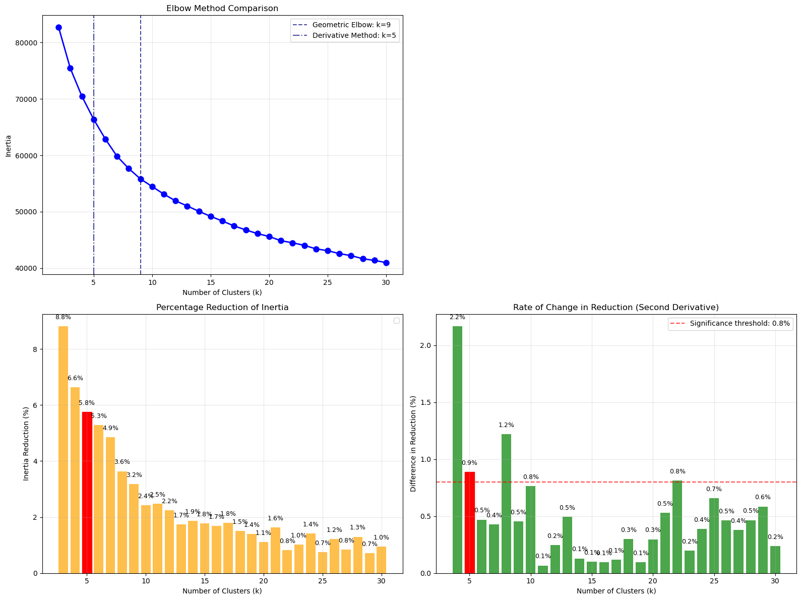

**_____________________________5 clusters___________________________**

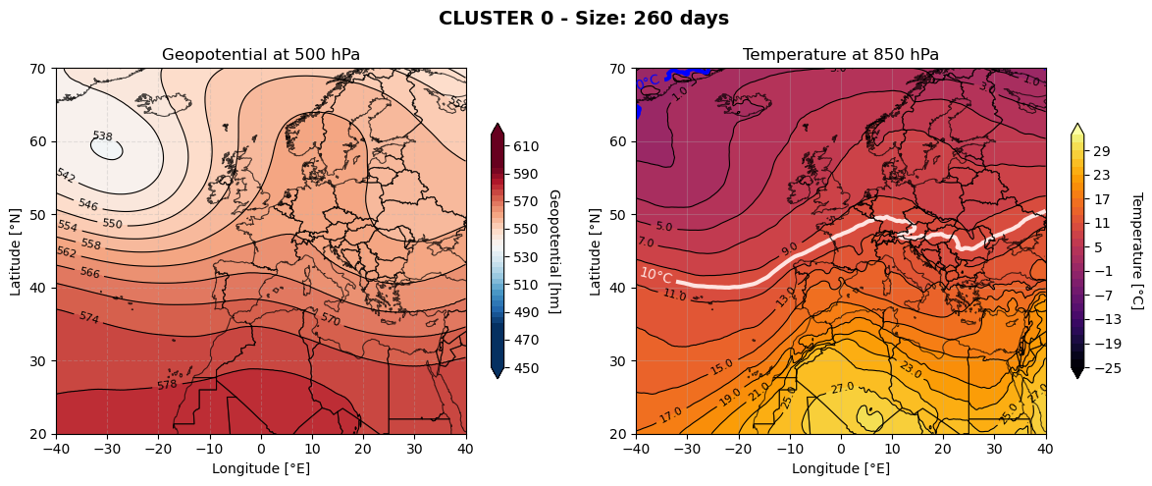

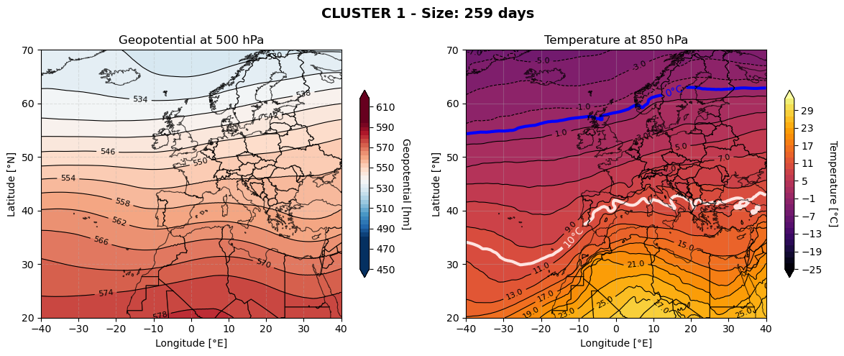

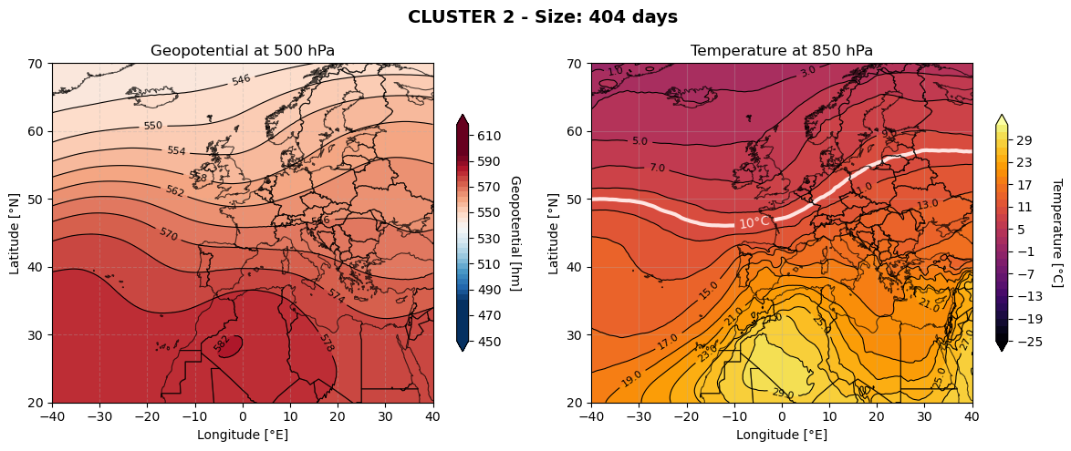

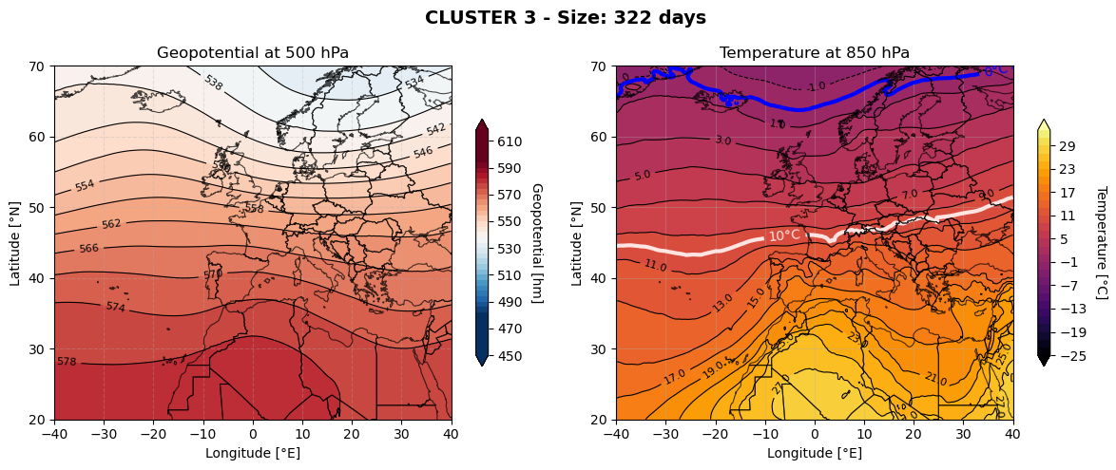

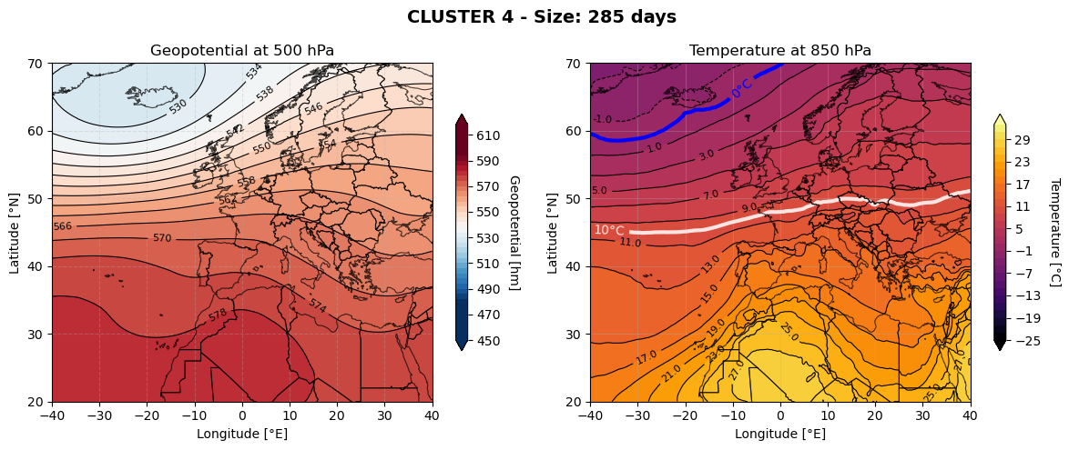

______ mappa esempio

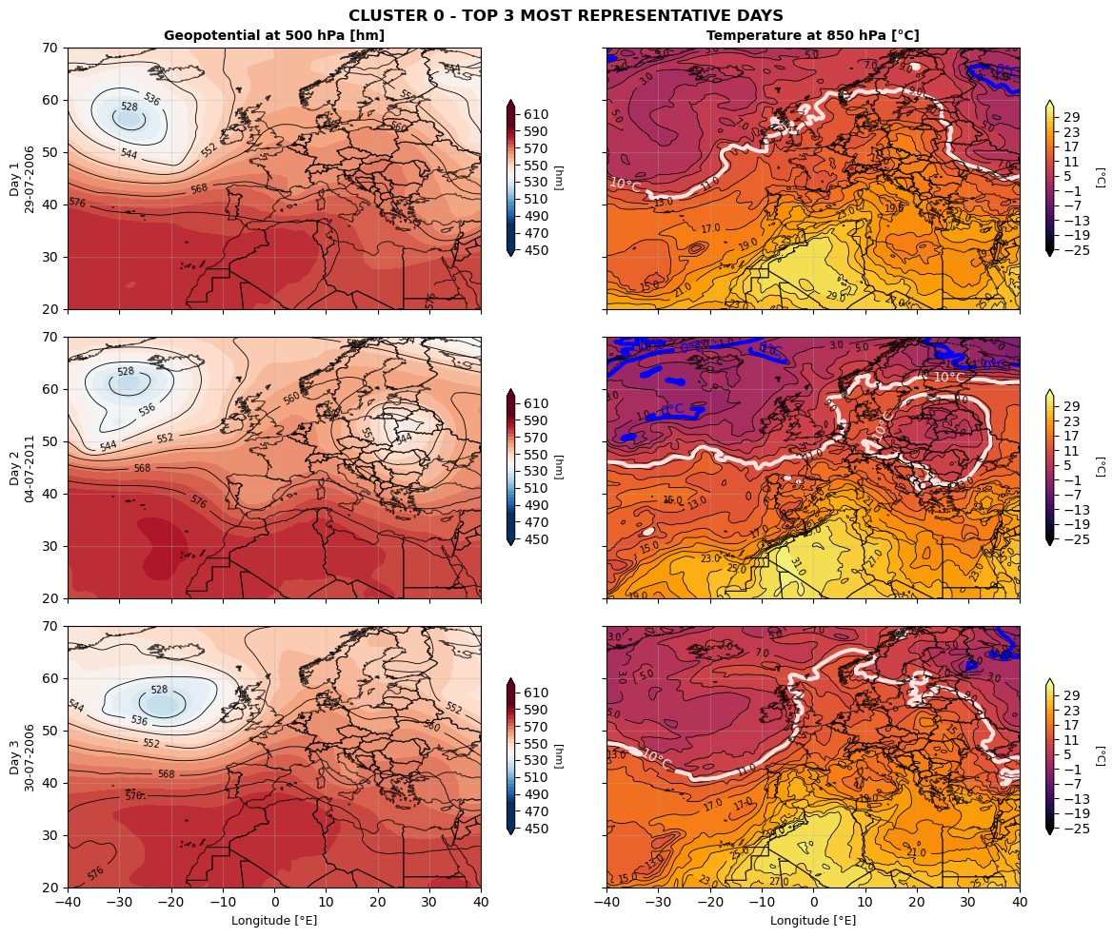

**_____________________________8 clusters___________________________**

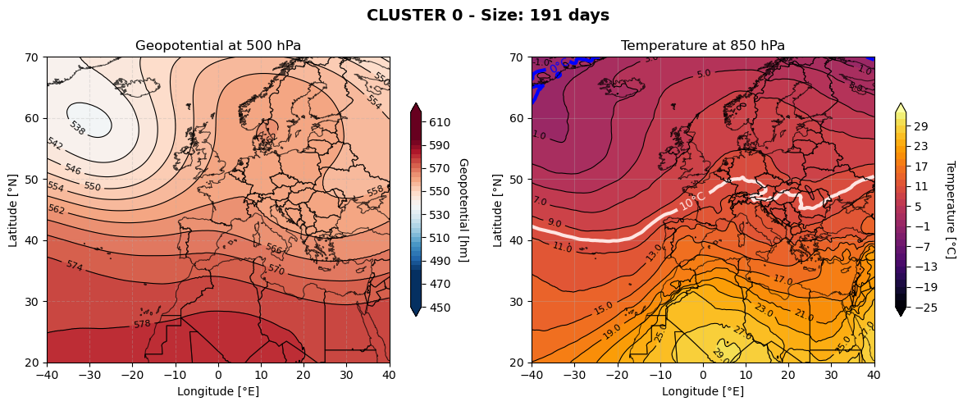

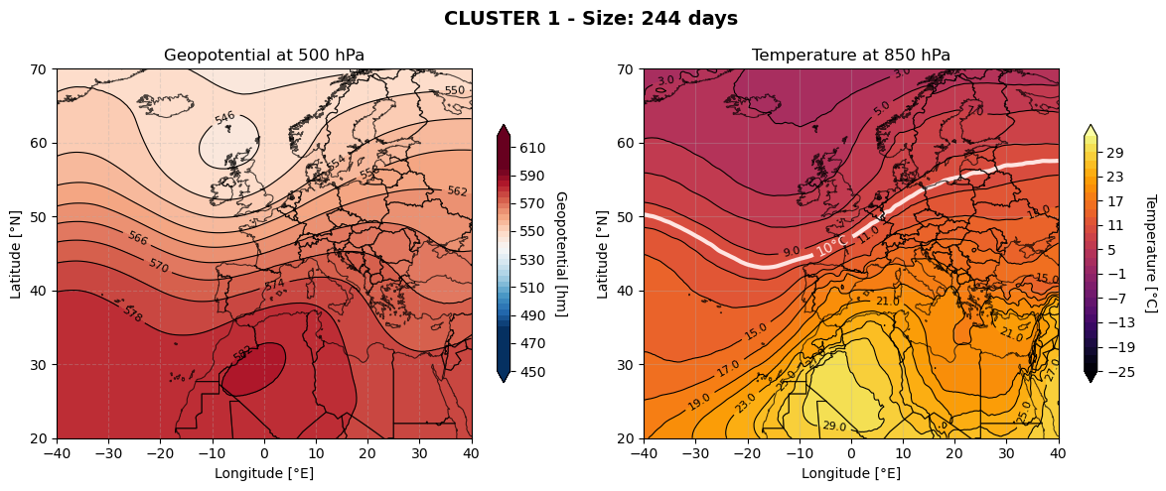

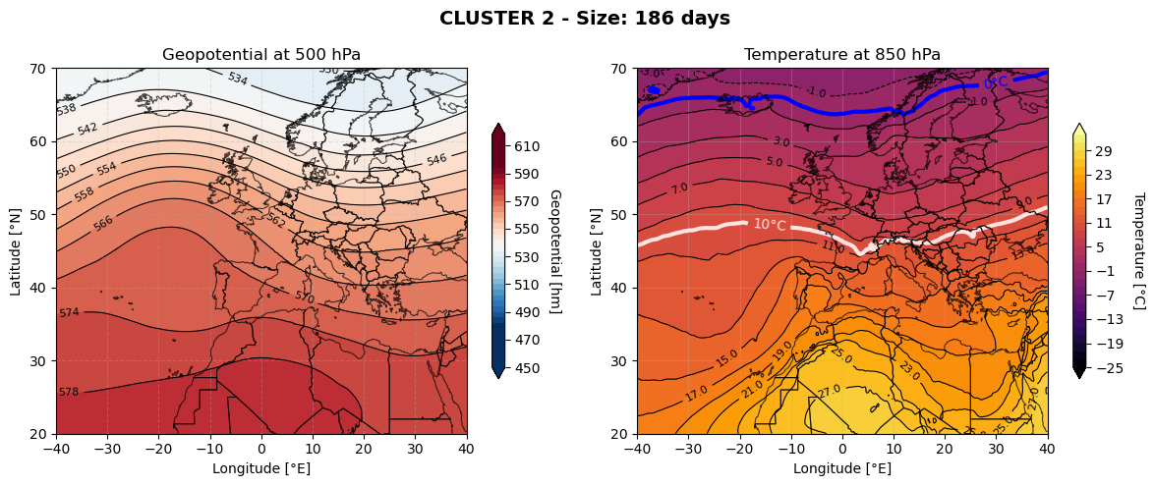

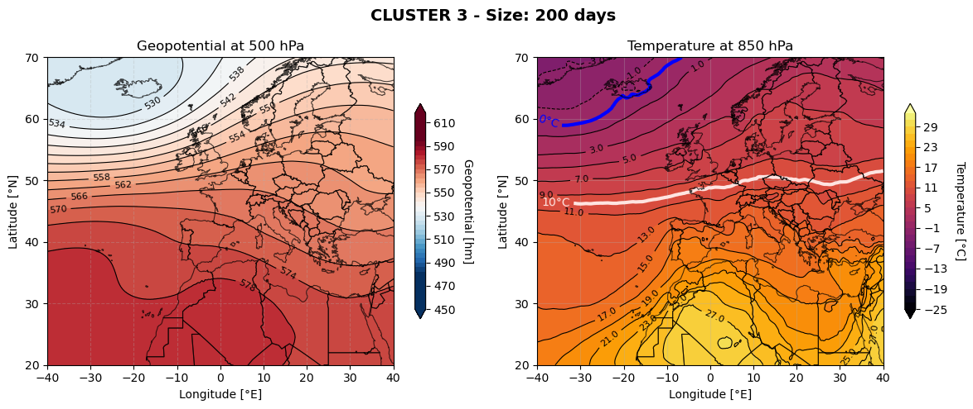

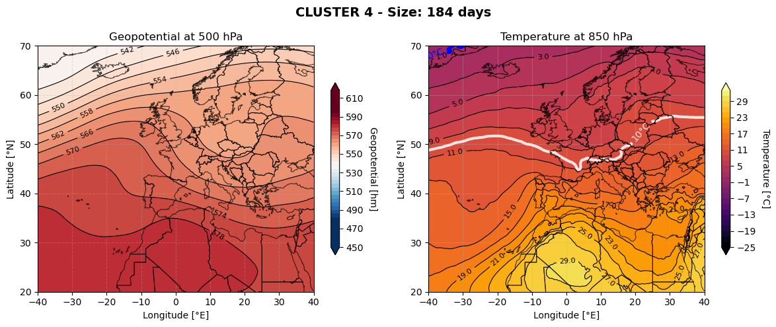

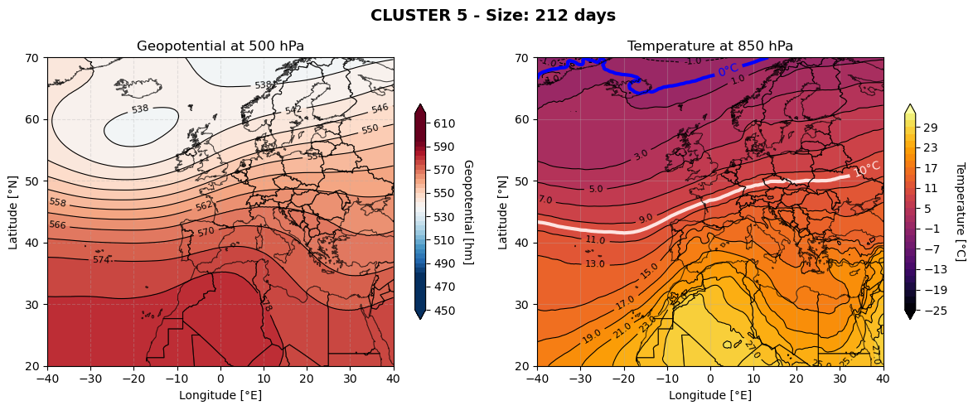

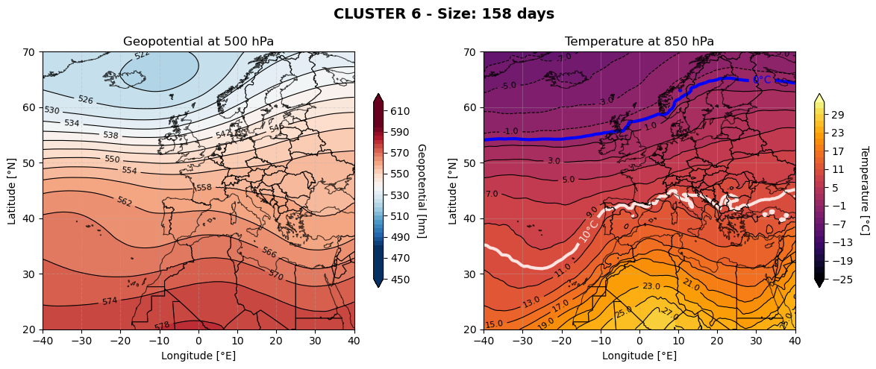

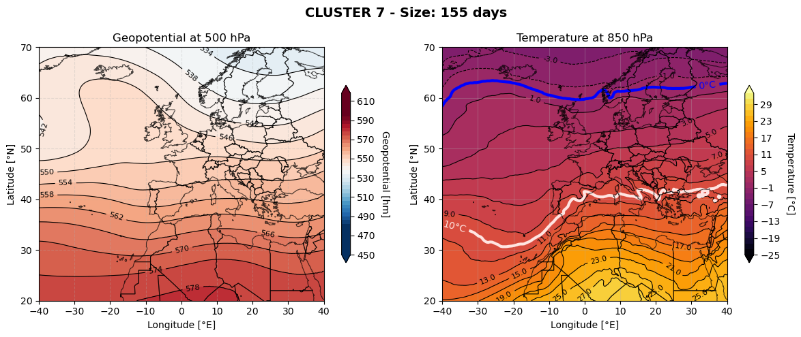

____ mappa esempio

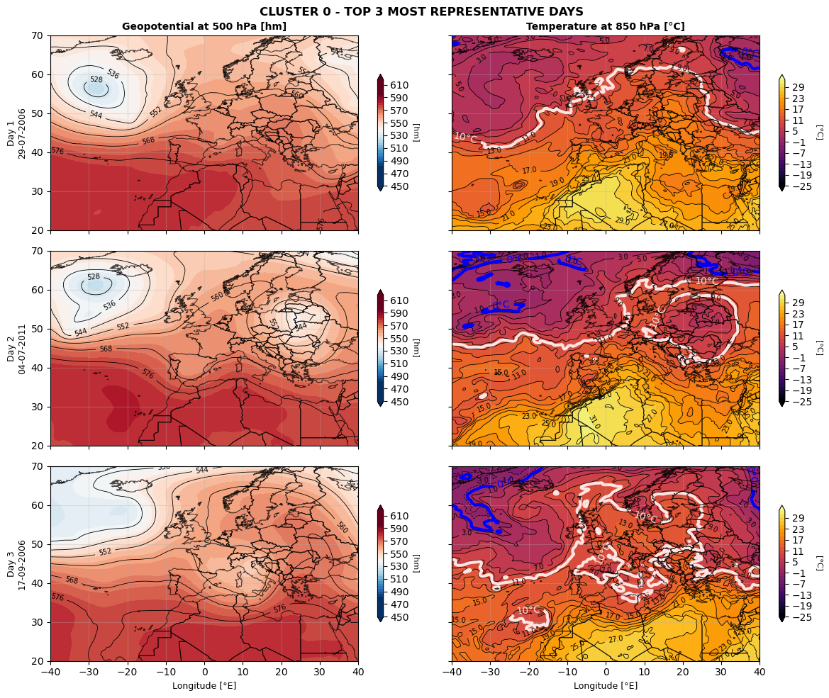

**_____________________________10 clusters__________________________**

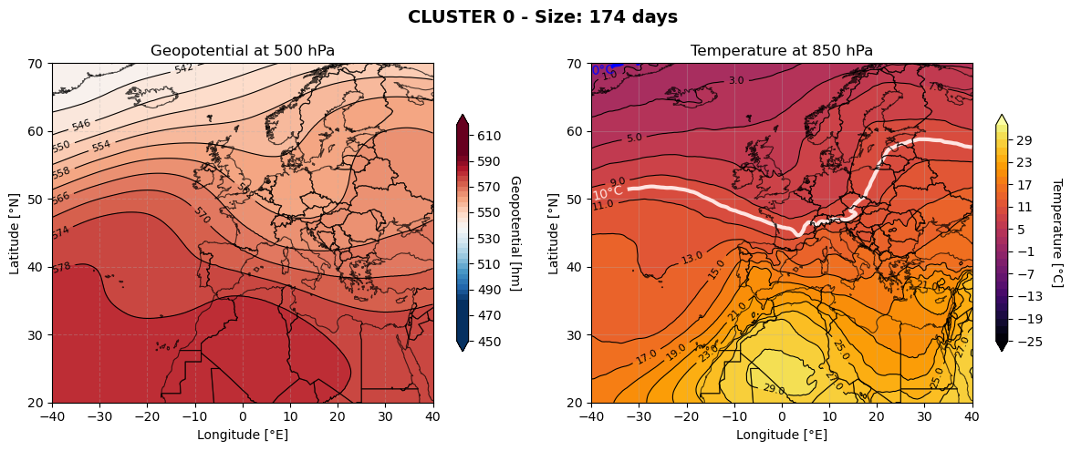

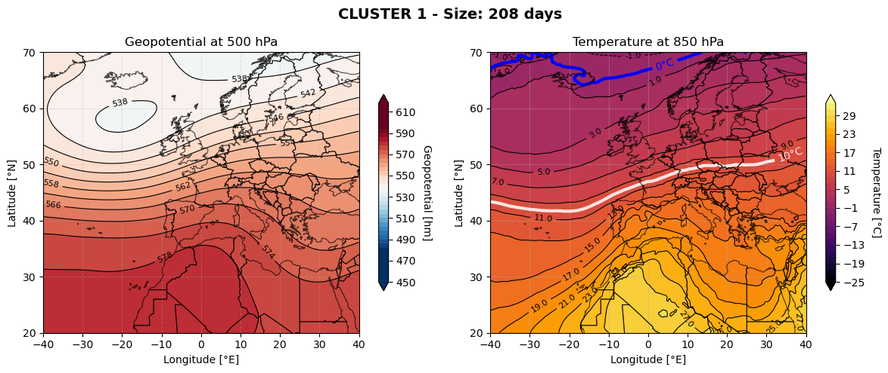

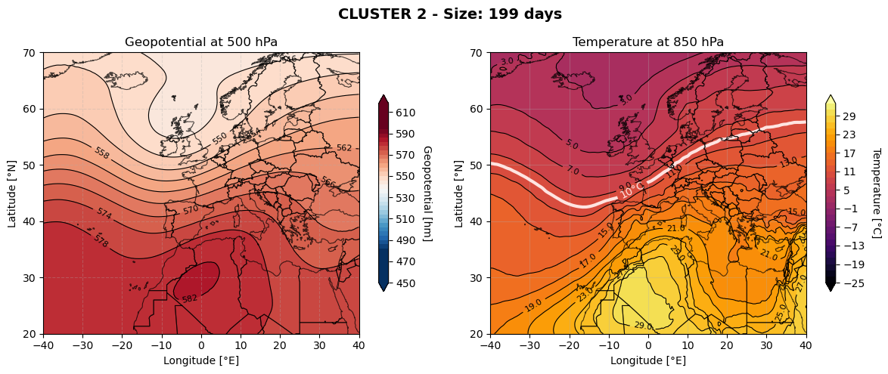

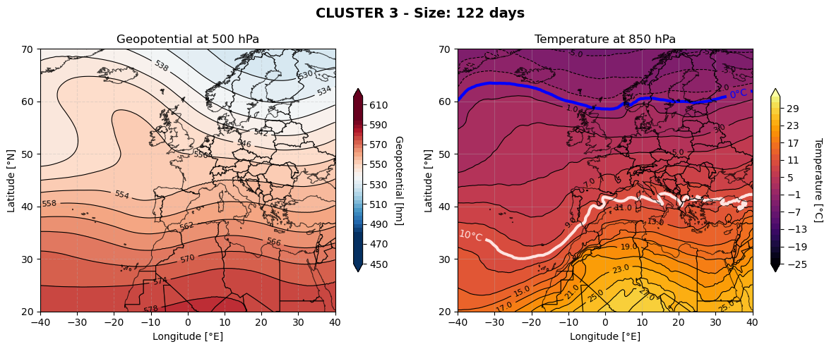

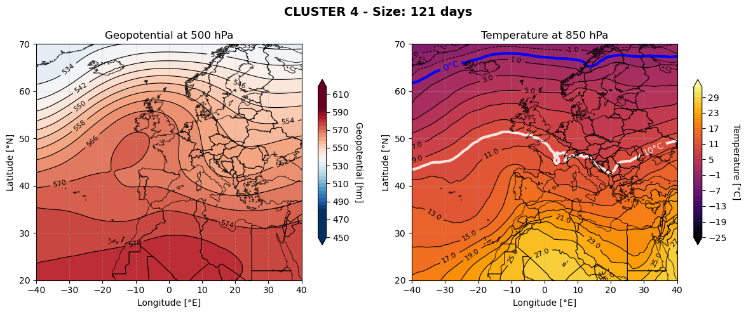

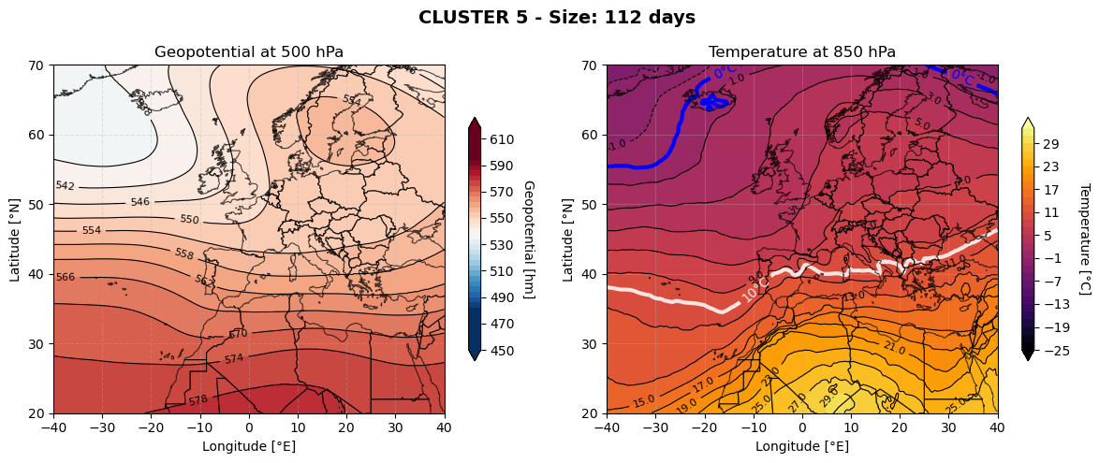

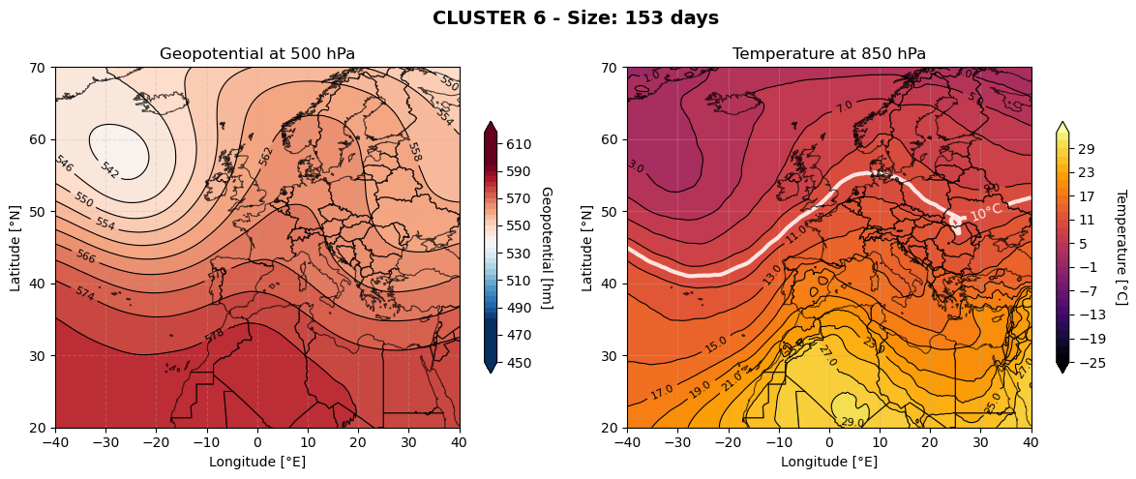

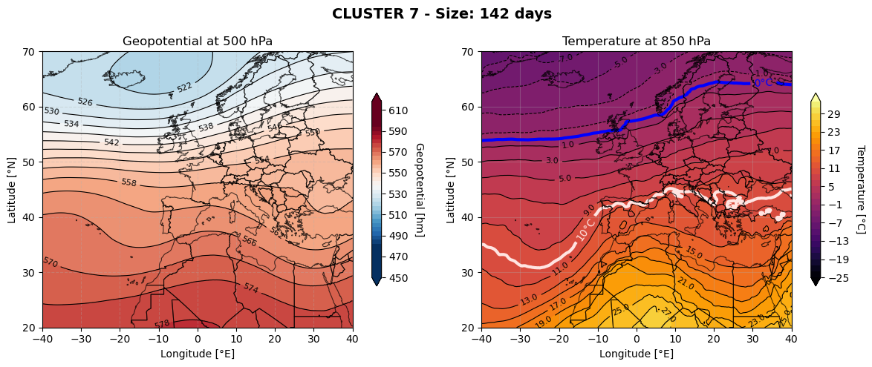

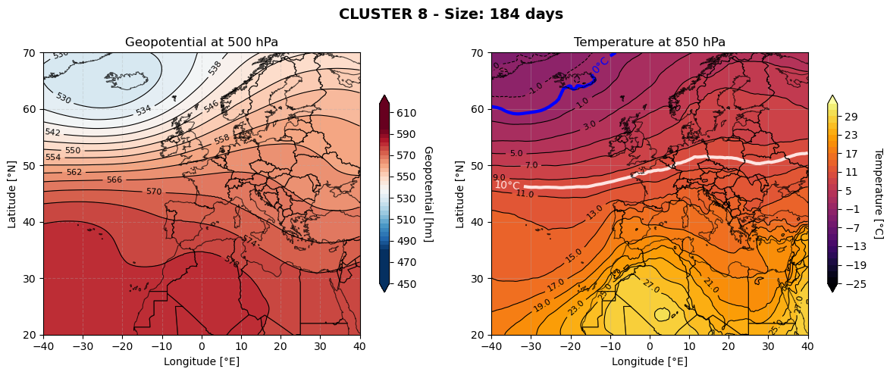

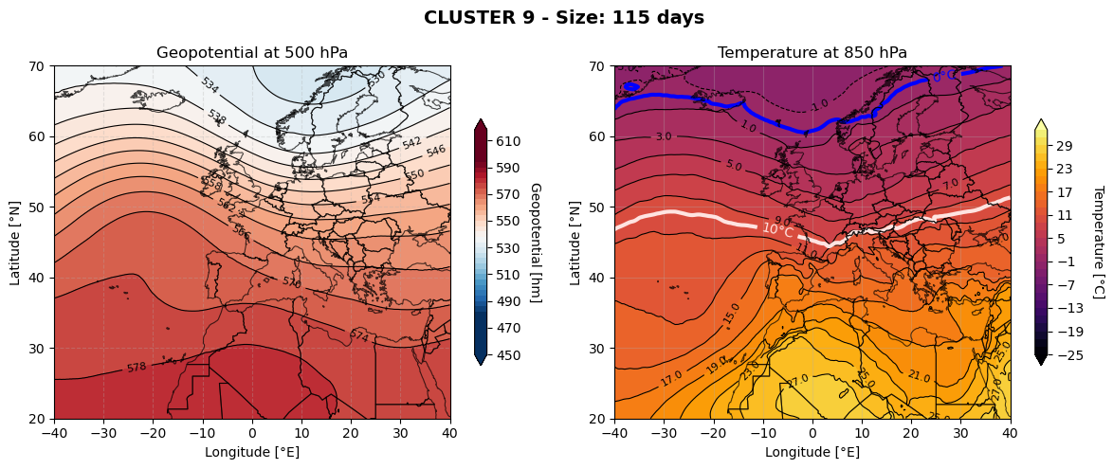

____ mappa esempio

**_______________________ jfmaond - INVERNO________________________ ________________________________________________________________**

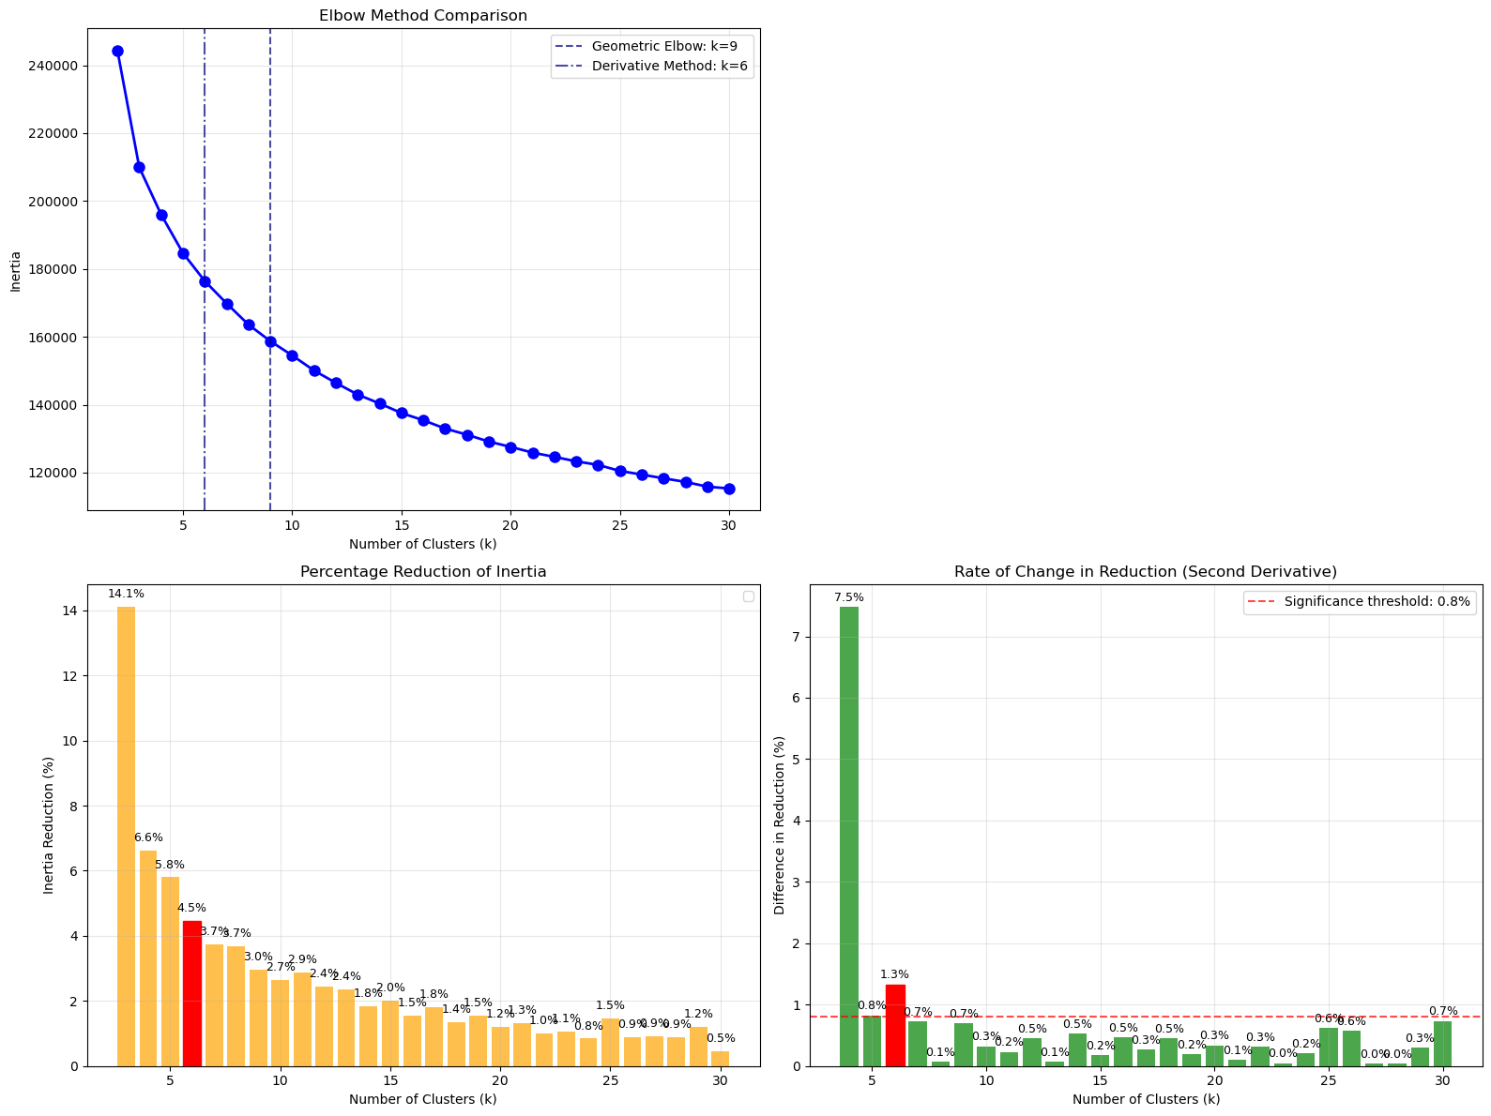

**_____________________________6 clusters___________________________**

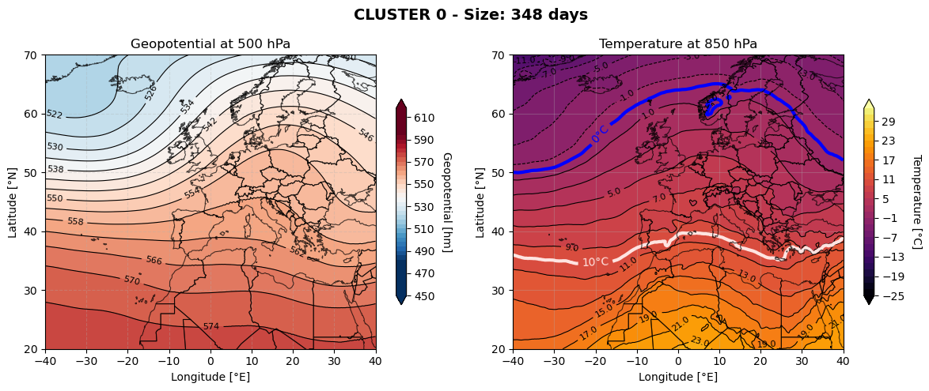

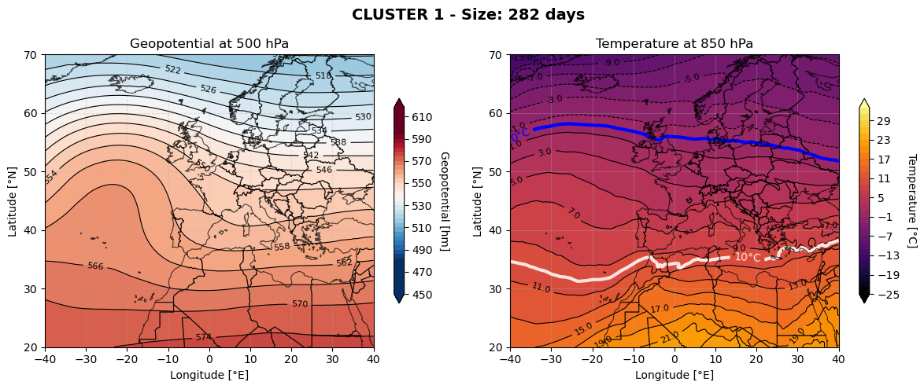

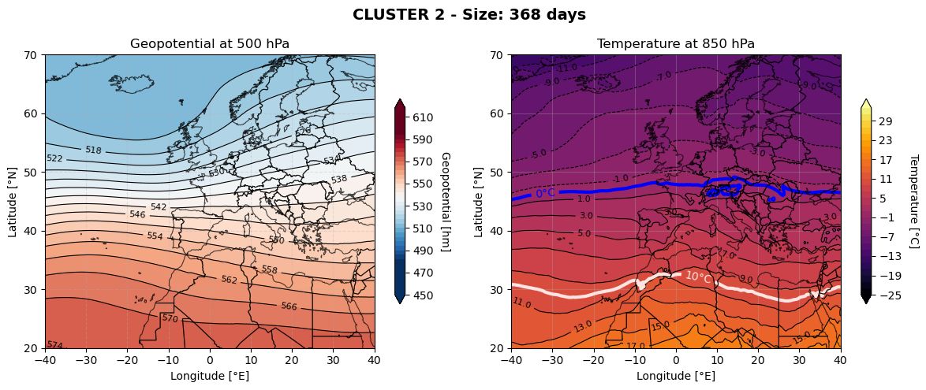

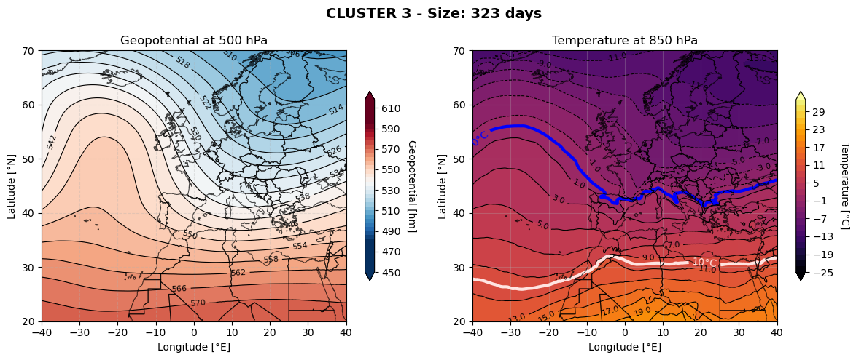

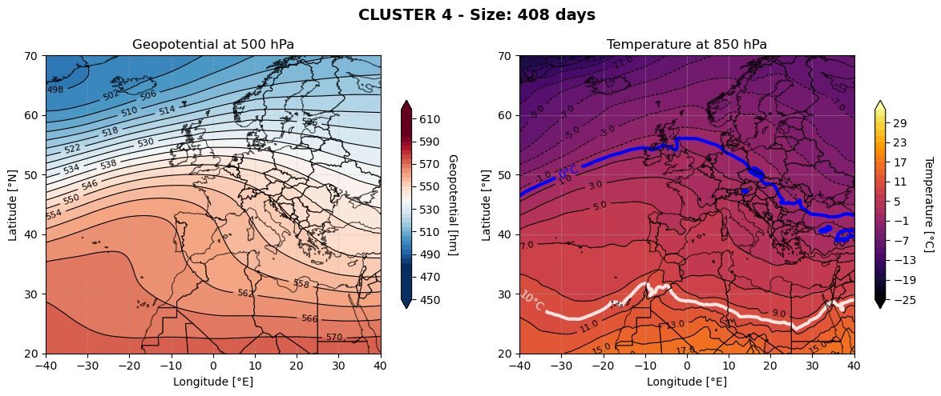

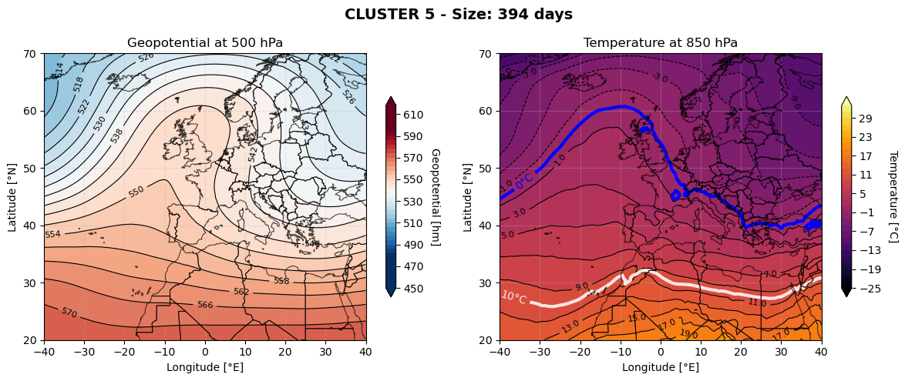

___ mappa esempio

